CONNECTING PHYSICAL DEVICES OVER

A NETWORK

**INTRODUCTION**

Cisco has estimated that 20 million devices will be connected to the internet by 2018, and 50 million by 2020.The concept of making a device connect itself over a network and follow commands given on the network uses the concept internet of things (IOT).

What is IOT?

Internet of Things (IOT) is an ecosystem of connected physical objects that are accessible through the internet. The ‘thing’ in IOT could be a person with a heart monitor or an automobile with built-in-sensors, i.e. objects that have been assigned an IP address and have the ability to collect and transfer data over a network without manual assistance or intervention. The embedded technology in the objects helps them to interact with internal states or the external environment, which in turn affects the decisions taken.

Why IOT?

An article by Ashton published in the RFID Journal in 1999 said, “if we had computers that knew everything there was to know about things – using data they gathered without any help from us – we would be able to track and count everything, and greatly reduce waste, loss and cost. This is precisely what IOT platform does for us. It enables devices/objects to observe, identify and understand a situation or the surroundings without being dependent on human help.

What is the scope of IOT?

Internet of Things can connect devices embedded in various systems to the internet. When devices/objects can represent themselves digitally, they can be controlled from anywhere. The connectivity then helps us capture more data from more places, ensuring more ways of increasing efficiency and improving safety and IOT security.

IOT is a transformational force that can help companies improve performance through IOT analytics and **IOT Security** to deliver better results. Businesses in the utilities, oil & gas, insurance, manufacturing, transportation, infrastructure and retail sectors can reap the benefits of IOT by making more informed decisions, aided by the torrent of interactional and transactional data at their disposal.

# Data Flow Diagram for IoT applications:

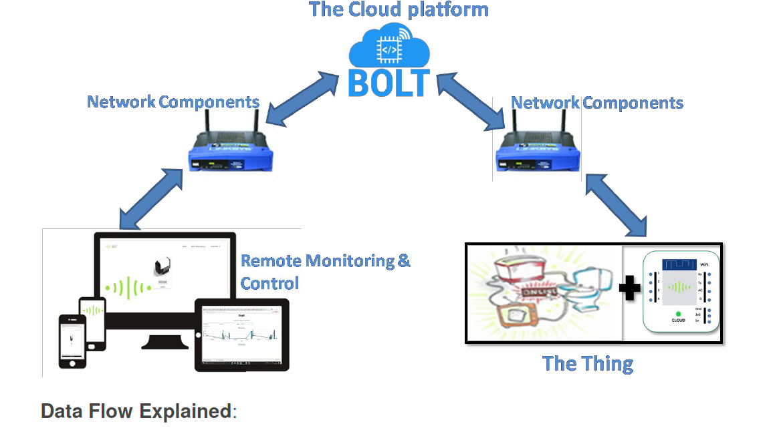

Figure Data Flow Diagram

**Data Flow Explained**:

**Remote Monitoring and Control**: Consists mainly of two components as explained below

Remote application: It is a user-oriented application with a GUI (Graphical user interface), that allows users to control or monitor IoT - enabled devices remotely over a network or internet. For example: Mobile apps, web apps.

Remote Access Devices: These include the PC / Laptops / Tablets or Mobile Phones that can run the Remote applications in a browser or as a standalone application Network component. It includes all networking components, like routers, switches, hubs, etc. which help in transporting information to and from the User Interface Application to the IoT-enabled devices. For GSM based things these can also be cell phone towers, antennas etc.

## The "Thing"

It is the IoT - enabled device which the end user can control or monitor, or a device which

can simply share its information with other machines (M2M). More on this will be explained

in the upcoming topics.

# The Thing

There are four main system components for the Internet of Things (IoT):

1. The Thing

2. The local network

3. The Internet

4. The cloud

The "Thing" is an embedded computing device (or an embedded system) that transmits and

receives information over a network (need not be able to interface with the internet directly)

for the purpose of controlling another device or interacting with a user. A Thing is also a

microcontroller or microprocessor-based device.

Hence a simple chair, TV, fan, microwave, fridge, sprinkler, bulb, etc. (the list goes on) on

their own cannot be called "Things" w.r.t. IoT because:

1. Most of the day to day things like a bed, chair, fan or a bulb does not have an embedded

systems or an information processing capability.

2. Even if they do have embedded systems built in, they do not have the capabilities to

transmit and receive information over a network. For example, washing machine, microwave

and electric stoves.

**Hence, the "Thing" should provide one or all of the below services:**

1. Identification and info storage (RFID tags, MAC address)

2. Information collection (Sensor networks, store sensor values)

3. Information processing (Understanding commands, filtering data)

4. Communications (Transmit and receive messages)

5. Actuation (Switch control, motor control)

Hence for anything to be called a "Thing" in IoT, we need to add one or all of the above

features to day to day things externally or have them inbuilt. That means you have to add an

embedded device to, let's say a chair, window, ceiling fan or bulb, for them to have the

above-mentioned capabilities.

**DESCRIPTION:**

This project is made on BOLT (IOT Cloud Platform) which is a Home Security Alert System that can be installed in our home premises. Now if you are away from your home you can use this system to detect any presence of human in your home and it starts buzzing alarm, flashing on led over it and sends an alert notification to you as email. You can always turn off the buzzer if the human detected is someone you know.

# Hardware Kit Components

Bolt (IoT Platform) – One Unit

Proximity Sensor – One Unit

Push Button – One Unit

LDR – One Unit

Piezo Buzzer – One Unit

LED – Two Units

Resistors (10KOhm + 330Ohm)



# Hardware Description



**Pins** - It has 5 GPIO pins and 1 ADC pins.

**Wi-fi Connectivity** -BOLT has Wi-Fi 802.11 b/g/n, 2.4 GHz channel frequency,

Automatic Soft-AP/Hotspot Mode - It automatically broadcasts its own Wi-Fi

network in case it can't connect to specified network.

**Integrated TCP/IP** -It has inbuilt TCP/IP support using which a device can be

connected to the internet.

**Multiple GPIO Control** – You can control multiple GPIOs (GPIO – general purpose

input output) using a single command

**UART** - 1 UART (Universal Asynchronous Receiver/Transmitter) operating at

2400/4800/9600/19200 baud.

**Programming Language Support** - Web language support makes it very easy to

use. We used HTML, CSS, JavaScript for building our app.

Remote API (application programming interface) further allows you to build applications using JavaScript.

**Micro USB Power port** - It is powered at 5 Volts by using a microUSB power adapter

**PWM pins -** The digital I/O pins dual up as PWM (pulse width modulation) pins.

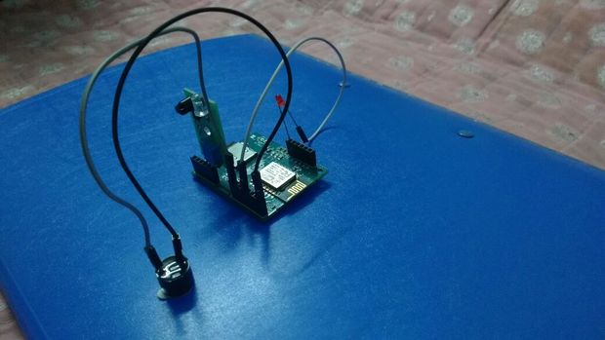

The above pic represents a home intrusion system , the components include proximity sensor, buzzer, LED, micro controller etc.

This device notifies a user through an email or a message whenever someone enters his home through a door or a window.